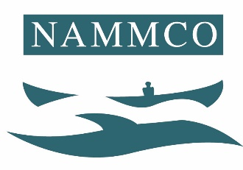

NAMMCO SCIENTIFIC COMMITTEE WORKING GROUP
ON
HARBOUR PORPOISES

Copenhagen, 19-22 March 2019

Draft Agenda

- CHAIRMAN WELCOME AND OPENING REMARKS
- ADOPTION OF AGENDA
- APPOINTMENT OF RAPPORTEURS
- REVIEW OF AVAILABLE DOCUMENTS AND REPORTS
  - Harbour Porpoise Workshop Tromsø 2018
    - Map of assessment units
    - Topics covered & modelling/assessment method
    - Conclusions & Recommendations
  - Harbour Porpoise Working Group 2013
    - Summary of Previous Work & Recommendations
- Greenland assessment
  - Stock identity
  - Biological parameters
  - Abundance estimation
  - Catch numbers
  - Population modelling & assessment
  - Management advice
- Norway assessment
  - Stock identity
  - Biological parameters
  - Abundance estimation
  - By-catch
    - By-catch numbers
    - Mitigation
  - Population modelling & assessment
  - Management advice
- Iceland assessment
  - Stock identity
  - Biological parameters
  - Abundance estimation
  - By-catch
  - Population modelling & assessment
  - Management advice
- Faroe Islands
  - Stock identity
  - Abundance estimation
  - By-catch
  - Population modelling & assessment
  - Management advice
- IMPACTS FROM ANTHROPOGENETIC STRESSORS
- KNOWLEDGE GAPS, FUTURE RESEARCH & RECOMMENDATIONS
- OTHER BUSINESS

