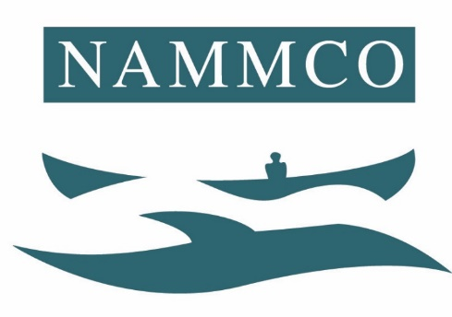

PROVISIONS OF THE NAMMCO
INSPECTION AND OBSERVATION SCHEME FOR THE
HUNTING OF MARINE MAMMALS IN MEMBER COUNTRIES

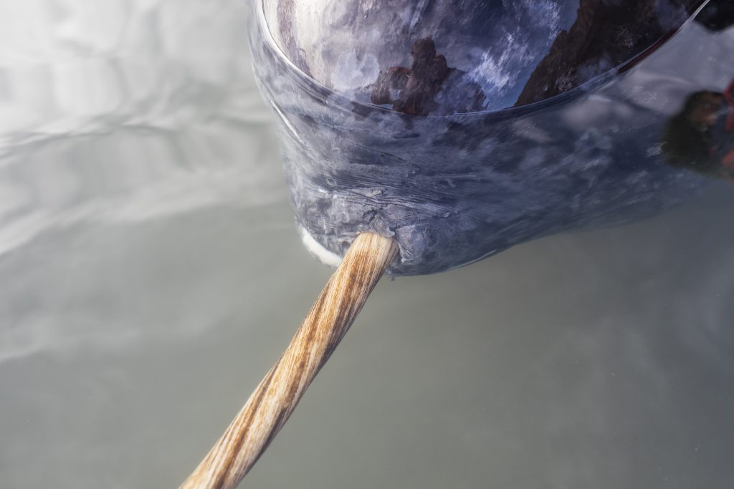

© North Atlantic Marine Mammal Commission

Please cite this report as:
NAMMCO-North Atlantic Marine Mammal Commission (2019). Provisions of the NAMMCO Inspection and Observation Scheme for the Hunting of Marine Mammals in member countries

Sections A and B adopted by Council in 1996
Guidelines to Section B adopted in 1997
Amended in 2006, all text revised in 2009
Section B including guidelines revised in 2019

Table of CONTENTS

SECTION A 4
COMMON ELEMENTS FOR NATIONAL INSPECTION SCHEMES FOR COASTAL WHALING IN NAMMCO MEMBER COUNTRIES 4
A.1 Introduction 4
A.2 Near-coast whaling operations 4
A.3 Off-coast whaling operations 5
SECTION B - INTERNATIONAL OBSERVATION SCHEME 6
General provisions 6
The Observer 6
Duties of the Member Countries 6
Duties of the observer 7
Duties of the observation subject 7
Duties of the Secretariat 7
APPENDIX 1 – Items for inclusion in whaling logbooks 8
APPENDIX 2 – Guidelines to Section B 10

SECTION A

COMMON ELEMENTS FOR NATIONAL INSPECTION SCHEMES FOR COASTAL WHALING IN NAMMCO MEMBER COUNTRIES

A.1 Introduction
The national inspection schemes include national inspectors who either
i) remain permanently on-board whaling vessels or at landing/receiving places during the hunting season, or
ii) carry out random control of hunting vessels and landing/receiving places,
or a combination of i) and ii).
The aim of these regulations is to establish a standard of common elements, which shall be a minimum requirement in the random control, included in national inspection schemes. In addition to these elements, the individual member countries may include new elements as considered appropriate in relation to national laws and regulations for their specific whaling activities.
The national authorities decide the extent of inspection within their own jurisdiction.

A.2 Near-coast whaling operations
A.2.0 In these provisions, near-coast whaling operations is defined as whaling from vessels which bring their catch fresh to land.
A.2.1 The relevant authorities in each NAMMCO member country (hereafter called "the national authorities") design and publish a whaling logbook. The captain on board vessels equipped to carry out whaling must keep the logbook continually updated during the hunting season. A minimum requirement for the whaling logbook is that it includes the information listed in Appendix 1- Items for inclusion in whaling logbooks.
A.2.2 In addition to the logbook the national authorities may develop and implement regulations for the electronic monitoring of information to enable the controlling authorities to ascertain the vessel's position and activities etc.
The electronic monitoring system shall as a minimum sample the following types of data:
i) Vessel activity - by continuous logging of time, position and speed of vessel
ii) Catching activity - by continuous logging of data on the use of the harpoon gun, hauling of whales etc
A.2.3 The national authorities implement an arrangement whereby national inspectors carry out random checks on whaling vessels and at landing/receiving places. The national authorities compile a set of provisions for this arrangement, which specify requirements for the inspectors’ qualifications and competence, duties, rights, etc.
A.2.4 One of the duties of the inspectors, as required by the national authorities, (cf. item A.2.3), shall be to examine the whaling logbook in order to check whether it has been filled in correctly, and in general to control that national regulations have been followed.
If an electronic monitoring system is mandatory, the inspector shall check the system certificates, that the seals of amplifiers and control boxes are not broken and that the system is activated. Sealed components shall not be broken by the inspector.
Inspectors shall

i) draw attention to violations of regulations on board whaling vessels or at landing/receiving places, and in these instances demand changes according to the regulations in effect;
ii) collect samples and record data in accordance with national and international requirements;
iii) report to their national authorities, and
iv) have access to the logbooks of the vessel, check the electronic monitoring system (see A.2.4) and have the right to communicate with the national authorities through the communication equipment of the vessel.
The national authorities develop a reporting form for use by the inspectors.
A.2.5 The national authorities develop and implement regulations for storage of the catch on board a vessel. Meat, blubber and "mattak" (hide, including a thin layer of blubber) from individual animals caught must be stored on board separately from other catches. Separation of these parts shall occur within a minimum of six hours after the catch report is made.

A.3 Off-coast whaling operations
A.3.0 In these provisions, off-coast whaling operations is defined as whaling where the whale is flensed on board vessels which are equipped to handle and store meat and blubber either frozen or chilled with ice, or preserved by other means, in connection with transport/storage.
A.3.1 The requirements referred to under A.2.1 and A.2.3 - A.2.5 also apply to off-coast whaling operations.
A.3.2 The national authorities may develop and implement regulations for the electronic transmission of information to enable the controlling authorities to ascertain the vessels position etc.
The regulations shall require the following types of reports:
i) Report of commencement of activity - report on time and place when leaving port or when weighing anchor
ii) Report of position - regular daily report on position.
iii) Report of catch - report on the time and position of the catch, and subsequent treatment of catch (i.e. flensing).
iv) Report of termination of activity - report on time and place when arriving at port or when anchoring

SECTION B - INTERNATIONAL OBSERVATION SCHEME

General provisions
- The purpose of this Observation Scheme is to collect reliable information on all kinds of hunting activities in the NAMMCO Member Countries. The objectives are to
- provide a mechanism for NAMMCO to oversee whether recommendations made by NAMMCO are implemented and national regulations are adhered to
- provide a foundation for the member states to evaluate whether a recommendation is serving its purpose or not
- contribute to the improvement of the national regulation of hunting activities in the Member Countries
- These objectives will be reached by NAMMCO appointing observers to observe hunting and inspection activities in NAMMCO member countries and the Committee on Inspection and Observation reviewing the observation activities and the implementation of NAMMCO recommendations in national legislations (see section 1).
- The information collected through the Observation Scheme shall be made available to any NAMMCO body requesting it.
- Observations of hunting activities can take place on board a vessel or on shore, including flensing, storage, landing or delivering of the catch.
- NAMMCO/the Council decides annually the scope of observation priorities for the coming year. The Secretariat is responsible for the practical administration and coordination of these activities.
- Deployment of observers according to this Scheme cannot be refused.

The Observer
- “Observer” means a person who is authorized and certified by the NAMMCO member countries to observe, monitor and collect information on all hunting related activities. The observer shall be independent and impartial, and have the knowledge, skills and abilities to perform all of the duties, functions and requirements specified in this Scheme.

Duties of the Member Countries
- Member countries shall take appropriate measures to ensure that observation of the relevant hunting activities can be carried out properly and efficiently. They shall require its hunters (cf. Section 4) to permit observers appointed by NAMMCO to perform their tasks and duties according to this Scheme.
- Member countries, together with NAMMCO, will concur to take appropriate action to ensure safe working conditions, the protection, security and welfare of observers in the performance of their duties, consistent with international standards and guidelines.
- Member countries shall ensure that their observers have no financial or beneficial interest in and, are paid in a manner that demonstrates financial independence from, the subject being monitored.

Duties of the observer
- The observer shall perform such work, including for scientific purposes, as NAMMCO may request.
- The observer shall execute their duties and functions in an unbiased manner on the basis of the guidelines adopted by NAMMCO (Appendix 2 – Guidelines to Section B). Observers are responsible to NAMMCO and can neither seek nor receive instructions from any other authority.
- The observer has no authority of jurisdiction and cannot intervene in any activities connected with the hunting activities.
- The observer shall check licences and relevant certificates, logbooks, all rooms on board or on land, hunting equipment and communication equipment which are relevant for the work. If an electronic monitoring system is mandatory the observer shall check the system certificates, that the seals of amplifiers and control boxes are not broken, and that the system is activated. Sealed components shall not be broken by the observer.
- If a national inspector is present at the time of the observation, the observer shall also oversee whether the inspection is done according to national regulations.
- The observer shall no later than 8 days after the end of the employment period submit a written report to NAMMCO on a NAMMCO observer report form.
- The observer shall ensure confidentiality of information collected under this Scheme.
- The observer shall introduce themselves to inspectors at sea, or in port upon arrival of the vessel.

Duties of the observation subject
- Each hunter (cf. section 4 and 13) shall extend such cooperation and assistance as may be required to enable the observers to carry out their duties. This cooperation shall include providing the observer with such access as may be required to the hunting operation and catch, including storage, flensing site, landing or delivering site.
- The observer is to be provided food and accommodations of a standard no less than provided to the hunters/crew.
- The observer is to be included in all emergency drills conducted.
- The master of a vessel shall notify the observer when an inspection party has signalled their intent to board the vessel.
- Masters of hunting activities (cf. section 4) shall not obstruct, intimidate, interfere with, influence, bribe or attempt to bribe an observer in the performance of his/her duties.

Duties of the Secretariat
- The Observer Scheme is administered by the Secretariat, in accordance with guidelines set down by NAMMCO.
- The Secretariat prepares an annual report of the Observation Scheme for the review of NAMMCO. The report shall include all relevant information and comments.
- The Secretariat shall send a copy of the observer’s reports to the member country in which the observations have taken place.
- APPENDIX 1 – Items for inclusion in whaling logbooks
I Vessel, whaling equipment and formalities
1 Registration number of the vessel
2 Call signal
3 Name of captain/licence holder
4 Name(s) of gunner(s)
5 Number of licence
6 Calibre of harpoon gun
7 Type of grenade used
8 Calibre of rifle
9 Number of grenades and propellant charges (and their serial numbers)
on board at end of last whaling trip
10 Number of grenades and propellant charges (and their serial numbers)
taken on board in connection with present whaling trip
11 Number of grenades and propellant charges (and their serial numbers)
on board at end of present whaling trip
II Activities
1 Port of departure
2 Date and time of departure from port or weighing anchor
3 Port of landing or position of anchoring
4 Time catch landed
5 Location catch landed
III The hunt
1 Species hunted
2 No. of whales caught in the season
3 Time first harpoon fired
4 Number of harpoons fired
5 Number of hits
6 Time of catch
7 Position of catch
8 Sex
9 Caught / lost
10 Location of flensing (flensing site)

In addition, the following items may be included:
Research data
1 Length
2 Sex
3 Foetus
4 Time search started
5 Time of first sighting of whale (species to be reported)
6 Position of sighting
7 Number of whales and groups of whales sighted (species to be reported)
8 Samples taken
IV Other
1 Comments
2 Date and signature (captain)

APPENDIX 2 – Guidelines to Section B
    - Appointment of observer
Council approves and appoints observers. An approved observer will continue to function until her/his services are redrawn/cancelled either by personal notification or notification by the (nominating) member country. Member countries are required to provide a minimum of two observer candidates to the pool of observers.
Nomination and approval process of observers
Member countries nominate observer candidates by notifying the Secretariat of their names and qualifications. The Secretariat subsequently forward the list of nominees with information on the qualification of the candidates to all members for their approval.
The member countries will have a month to consider the nominations after which the candidates are considered approved.
A reservation to a candidate from a member country must be communicated to the Secretariat and all member countries within this month. It is understood that a reservation to the appointment of a candidate is a reservation to his/her appointment as a NAMMCO observer in any area of activity.
These candidates shall not be included in the observer corps.
    - Competence, training etc. of observers
The requirements for the professional, linguistic and safety at sea qualifications of the observers are the following: Observers must have at least the same level of professional competence as that required of inspectors in the country where the observations are to take place. Exemption from this requirement can be given by the country where the observations are to take place.

For safety reasons, the language competency of observers must be taken into consideration. An observer on board a hunting vessel must be able to communicate spontaneously with the crew. For communication on land, a translator may be used.

In order to ensure that the persons appointed as observers are sufficiently informed about the relevant hunting regulations and the duties of national control personnel, observers shall participate in whatever training courses are compulsory for control personnel in the member countries where the observations are due to occur. If such courses are not held, or if the observer is unable for other reasons to participate in such courses, the observer must receive other relevant training, developed in co-operation between the national authorities and NAMMCO.
    - Duties of the observer
Observation activities can be carried out in four areas:
- observation of whaling carried out with the use of a harpoon gun or of flensing of whales taken with a harpoon gun;
- observation of sealing or forms of whaling other than with harpoon guns, or the flensing of animals from such hunting;
- observation of the landing/delivery of marine mammal catches;
- observations of national marine mammal inspection activities

The observer must check all the points listed for the hunt observed. Check lists are developed for every specific hunt.

Reports
No later than eight days after the end of the employment period the observer must submit a written report to the NAMMCO Secretariat. The report shall consist of the individual hunt event check lists, NAMMCO hunting form (active hunting days etc, statistics) The language of the report shall be either English or a Scandinavian language.

General conduct of observers
During the exercise of their duties, observers shall conduct themselves with appropriate tact and respect. Upon arrival at a vessel, a landing/receiving station or other place where observation duties are carried out, the observer shall always display their authorisation and identification card to the person in charge.

Confidentiality
Observers shall ensure the confidentiality of their duties and shall not report on observations carried out under the NAMMCO Control Scheme to any other parties than the Secretariat.
    - ADMINISTRATION OF THE SCHEME
Plans for observation and activities
By 1 May each year the Secretariat in cooperation with CIO develops a proposal for the Council for the scope and range of observation activities during the following year in accordance with budgeted funds for these activities. The Council shall approve this proposal by 1 June.

The Secretariat, in co-operation with control authorities in respective member countries, then develops a specific plan for observation activities. The plan shall, among other things, define the time frame for observation activities and shall specify the observation areas for each observer. The Secretariat may for practical reasons, and in co-operation with the authorities of the relevant member countries, make changes in the plan if necessary. The detailed plan of observation activities shall only be known to the control authorities in the relevant member countries and the Secretariat.

Employment of observers
When a detailed plan of observation activities for the year is finalized, those observers who will be called upon for active observation will receive an employment contract from the Secretariat. When both parties sign this, the observer will receive an identification card, as well as other relevant documentation necessary for his/her duties. The observer shall return his/her identification card to the Secretariat together with the final report of activities. He/she shall then receive a letter from the Secretariat confirming his/her completion of duties according to the Scheme.

